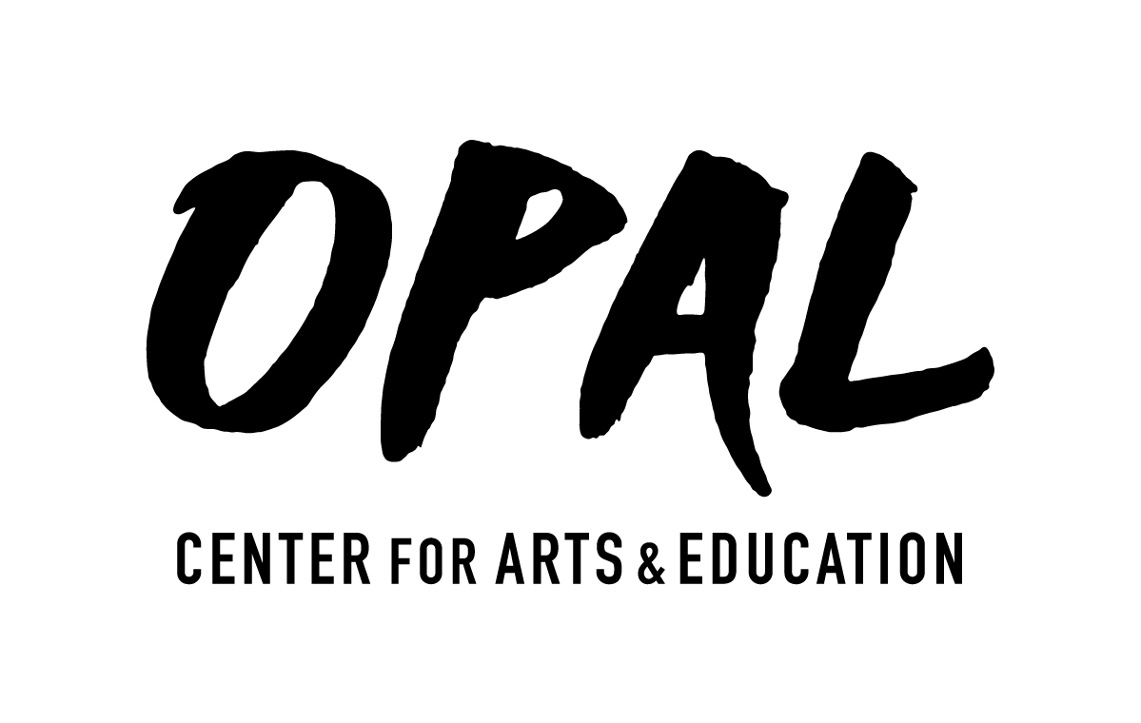

PROGRAM PROPOSAL FORM
Primary Contact Name/Director _________________________________________________________
Phone _____________________________ Email ___________________________________________
Mailing Address/City, State, Zip__________________________________________________________
Title of play or show _________________________________________________________________
Brief description (include whether this program will require royalties and who owns rights.)
__________________________________________________________________________________
__________________________________________________________________________________
__________________________________________________________________________________
Number of Cast _____________________
Circle either Yes or No to each of the following:
Sound system: Yes / No Special Stage Lighting: Yes / No Projector: Yes / No Spotlight: Yes / No
Does your show involve fire, blades, or dangerous items? Yes / No
Do you have a tech person to run lights/sound? Yes / No
OPAL will promote your event online through email, Facebook, and the OPAL website as well as sending a press release to the Cottage Grove Sentinel, Register-Guard, and Eugene Weekly.
The Opal Center will assist/reimburse with expenses for Theater performances with props and sets.
Send completed proposals to: ocae@opalcentercg.org

